**Implementation in the juiceShop CI/CD pipeline:**

Tool chosen: **jsFuzz** -> <https://github.com/fuzzitdev/jsfuzz>

* Implement the a function named “fuzz” with only one parameter, “buff”, in a js module (not done as modifying the project’s application is not one of our goals)
* Install jsFuzz in the Project with npm: npm install –g jsfuzz
* Run jsfuzz: jsfuzz ./path/to/the/specified/module corvus

**Reasoning of the tools chosen:**

Both tools, have been chosen due to its simplicity in theirs implementations, Little knowledge to use and easy troubleshooting, allowing us to utilice this in a fast but efficient manner.

We Implement it, creating the module fuzz.js, in the folder my_fuzzing_test inside the juiceShop application, containing the next content:

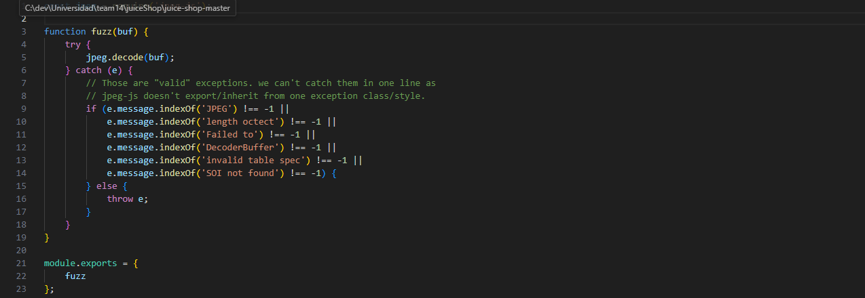

This is our target fuzzing example function, after implementing this, we just have to install the dependency needed into the Project and use it to check vulnerabilities:

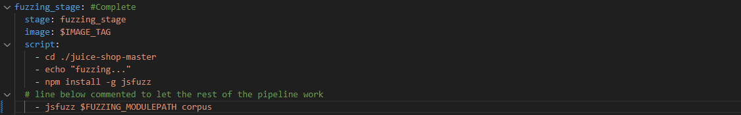

Giving us the next result, proving that it Works in the pipeline as intended:

